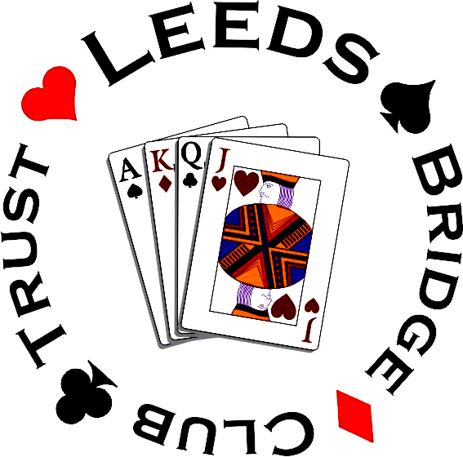

Oliver Cowan Bridge Events presents, face to face for the first time in 5 years,

LEEDS BRIDGE CLUB SWISS PAIRS

Sunday 12th May 2024 starting @ 12pm

At Leeds Bridge Club, Moor Allerton Sports & Social Centre, Stonegate Road, Leeds LS17 6EL
There will be 7 x 6 board matches and this event is fully blue pointed with masterpoints being given for all matches won or drawn as well as for final finishing position.
The winning pair will receive the Leeds Bridge Club Shield while there will also be a prize for the leading non-expert pair and other spot prizes.
Tea/Coffee, biscuits and sweets are included in the entry price and there will be a fully licensed bar for purchasing alcoholic and soft drinks.

Entry fee per pair only £50, which includes afternoon tea in the break. Entries are limited to 25 tables so early entry is advised. Please send names and EBU numbers for both players to ocbridgecomps@gmail.com
Tournament Organiser: Oliver Cowan (07946 393033)
BACS details for payment of entry fee: Sort Code 20-48-95 Account Number 43186903 Account name Oliver Cowan Bridge Ltd. Please reference Leeds + Surname

DATA PROTECTION – This event is being run by Oliver Cowan on behalf of Leeds Bridge Club, players providing the personal information on this form should note that this will be collected, stored, used and protected in line with the Oliver Cowan Bridge Club GDPR Privacy Notice as published on the Oliver Cowan Bridge Club website http://www.bridgewebs.com/olivercowan

